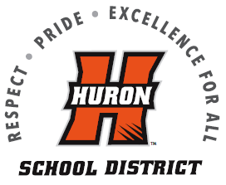 Huron Public School District
Middle School and High School Student A La Carte Privilege Form

This form is for the parents/guardians of children attending Huron Public School District that choose to NOT ALLOW their children to purchase any a la carte items, such as: a second entrée, extra milk at mealtime, or any additional items beyond the one meal provided from our breakfast/lunch menu.

By signing this form, any child listed on this form will NOT have a la carte privileges.

1. _____________________________ _____ ______________
Student name Grade School
2. _____________________________ _____ ______________
Student name Grade School
3. ______________________________ _____ ______________
Student name Grade School
4. ______________________________ _____ ______________
Student name Grade School

Date: ____________

Parent/Guardian Name (print name please): _________________________________

Parent/Guardian Signature: __________________________________________

Please return this completed and signed student a la carte privilege form to:
Huron Public Schools Nutrition Office
1045 18th Street S.W
Huron, SD 57350
or
Email to amanda.reilly@k12.sd.us
For any questions, please call Nutrition Office at (605) 353-6909

This institution is an equal opportunity provider.

