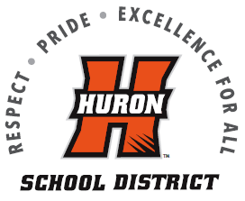 Huron Public School District
School Meal Account Refund Request Form

If your child will no longer be attending Huron Public School District and you would like to request a refund of any remaining meal account balance, please provide us with all student information below. You must also include the parent/guardian name and address for the check to be mailed out. Form must be dated and signed by the parent/guardian. Checks will be mailed out after the next Board of Education Meeting.

1. _____________________________ _____ ______________
Student name Grade School
2. _____________________________ _____ ______________
Student name Grade School
3. ______________________________ _____ ______________
Student name Grade School
4. ______________________________ _____ ______________
Student name Grade School

Parent/Guardian Name: ____________________________
(Refund check will be made out to this individual)

Address: __________________________
__________________________
__________________________

Date: ____________

Parent/Guardian Signature: __________________________________________

Please return this completed and signed refund request form to:

Huron Public Schools Nutrition Office
1045 18th Street S.W
Huron, SD 57350
or
Email to amanda.reilly@k12.sd.us
For any questions, please call Nutrition Office at (605) 353-6909

This institution is an equal opportunity provider.

